**Microprocessor and Computer Architecture Laboratory**

**UE19CS256**

**4th Semester, Academic Year 2020-21**

Date: 19-02-2021

|  |  |  |
| --- | --- | --- |
| Name: Atul Anurag | SRN: PES2UG19CS075 | Section: B |

Week#4

Program Number: 1

**Write an ALP to implement C[k] =a[i]+b[j]**

1. ARM Assembly Code (1).

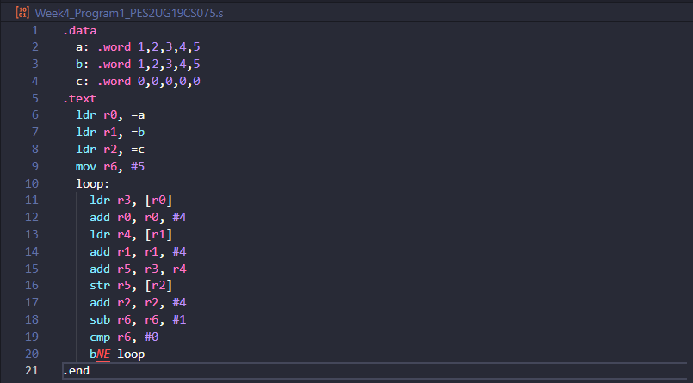

1. Output Screen Shot (One Example of your choice)

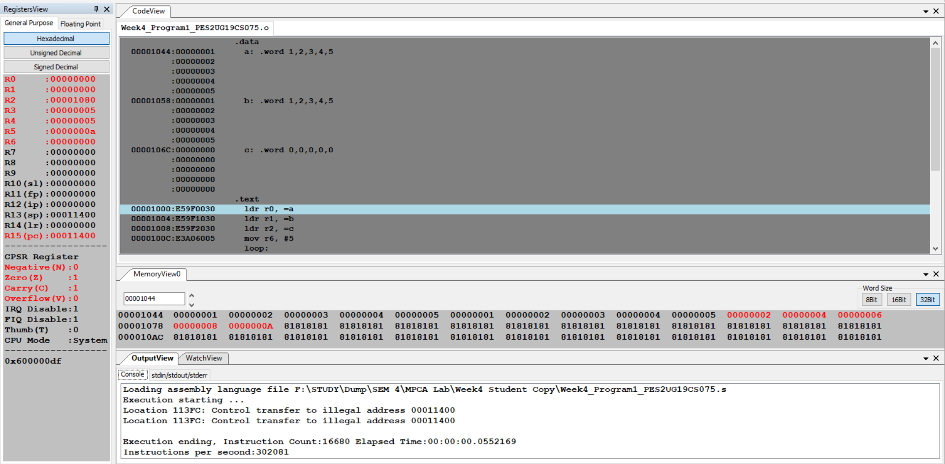

1. Output Table for the program(1)

|  |  |
| --- | --- |
| a: .word 1, 2, 3, 4, 5  b: .word 1, 2, 3, 4, 5  c: .word 0,0,0,0,0 | |
| **After Execution The content of array C is** | |
| **2** | **00000002** |
| **4** | **00000004** |
| **6** | **00000006** |
| **8** | **00000008** |
| **10** | **0000000A** |

Week#4

Program Number: 2

**Write an ALP to implement c[k] = a[i] * b[j]**

1. ARM Assembly Code (1).

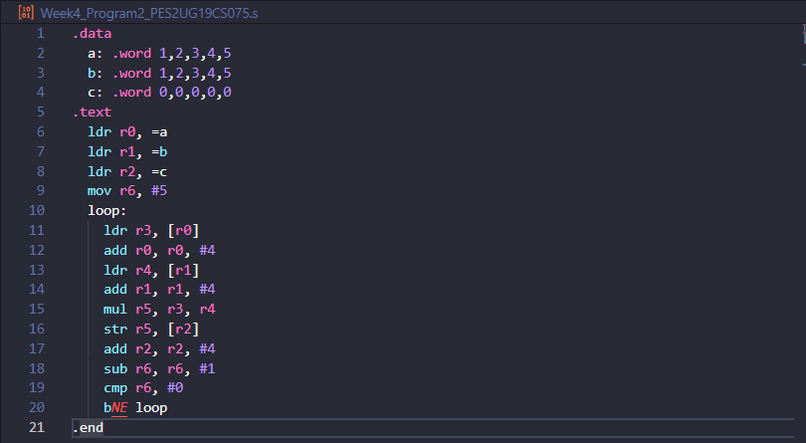

1. Output Screen Shot (One Example of your choice)

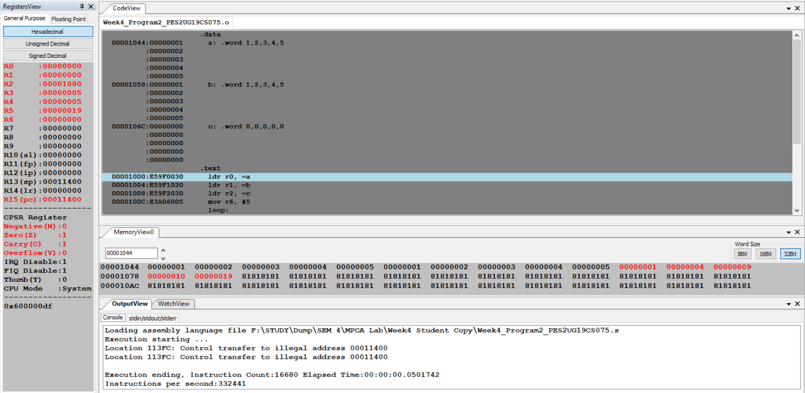

1. Output Table for the program(1)

|  |  |
| --- | --- |
| a: .word 1, 2, 3, 4, 5  b: .word 1, 2, 3, 4, 5  c: .word 0,0,0,0,0 | |
| **After Execution The content of array C is** | |
| **1** | **00000001** |
| **4** | **00000004** |
| **9** | **00000009** |
| **16** | **00000010** |
| **25** | **00000019** |

Week#4

Program Number: 3

1. **Write an ALP to perform Convolution using MUL instruction (Addition of multiplication of respective numbers of loc A and loc B)**
2. ARM Assembly Code (1).

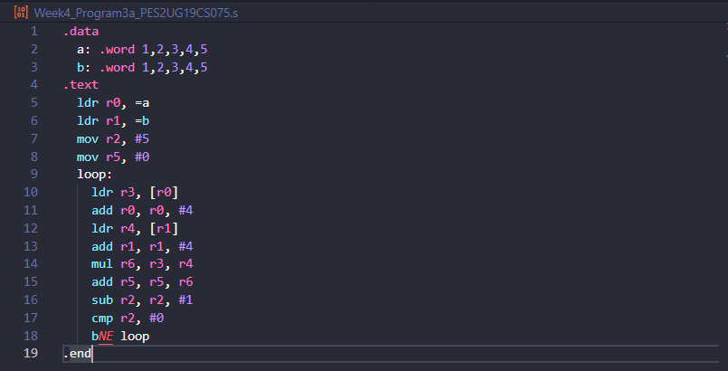

1. Output Screen Shot (One Example of your choice)

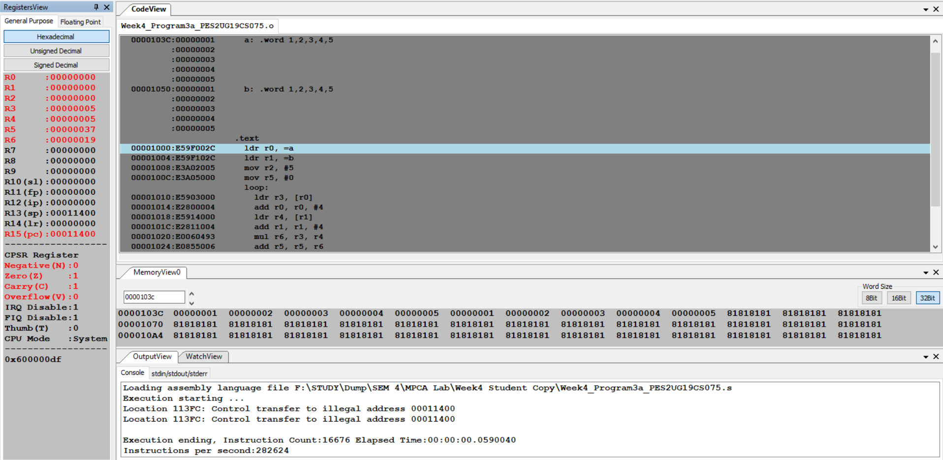

1. Output Table for the program(1)

|  |  |
| --- | --- |
| a: .word 1, 2, 3, 4, 5  b: .word 1, 2, 3, 4, 5 | |
| R5 | **(1*1)+(2*2)+(3*3)**  **+(4*4)+(5*5)**  **=55=00000037** |

1. **Write an ALP to perform Convolution using MLA instruction (Addition of multiplication of respective numbers of loc A and loc B).**
2. ARM Assembly Code (1).

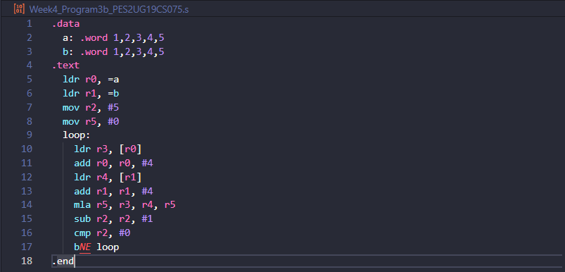

1. Output Screen Shot (One Example of your choice)

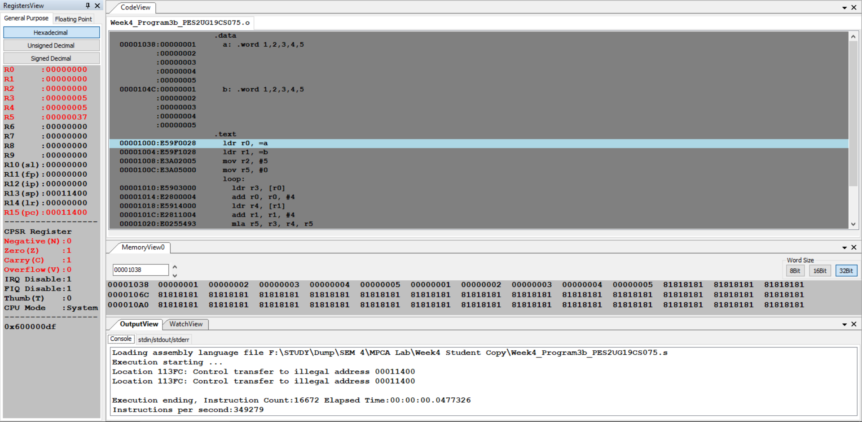

1. Output Table for the program(1)

|  |  |
| --- | --- |
| a: .word 1, 2, 3, 4, 5  b: .word 1, 2, 3, 4, 5 | |
| R5 | **(1*1)+(2*2)+(3*3)**  **+(4*4)+(5*5)**  **=55=00000037** |

Week#4

Program Number: 4

**Write an ALP to read from a 2D array such that**

**B=a[i] [j]**

1. ARM Assembly Code (1).

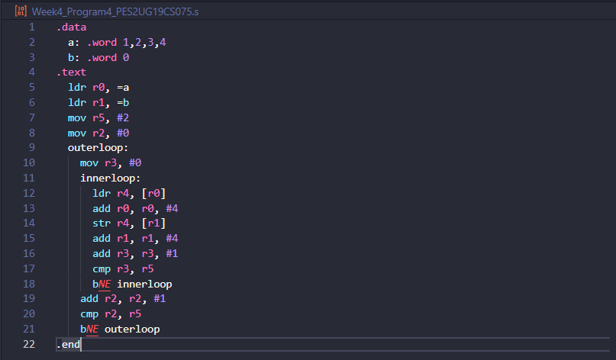

1. Output Screen Shot (One Example of your choice)

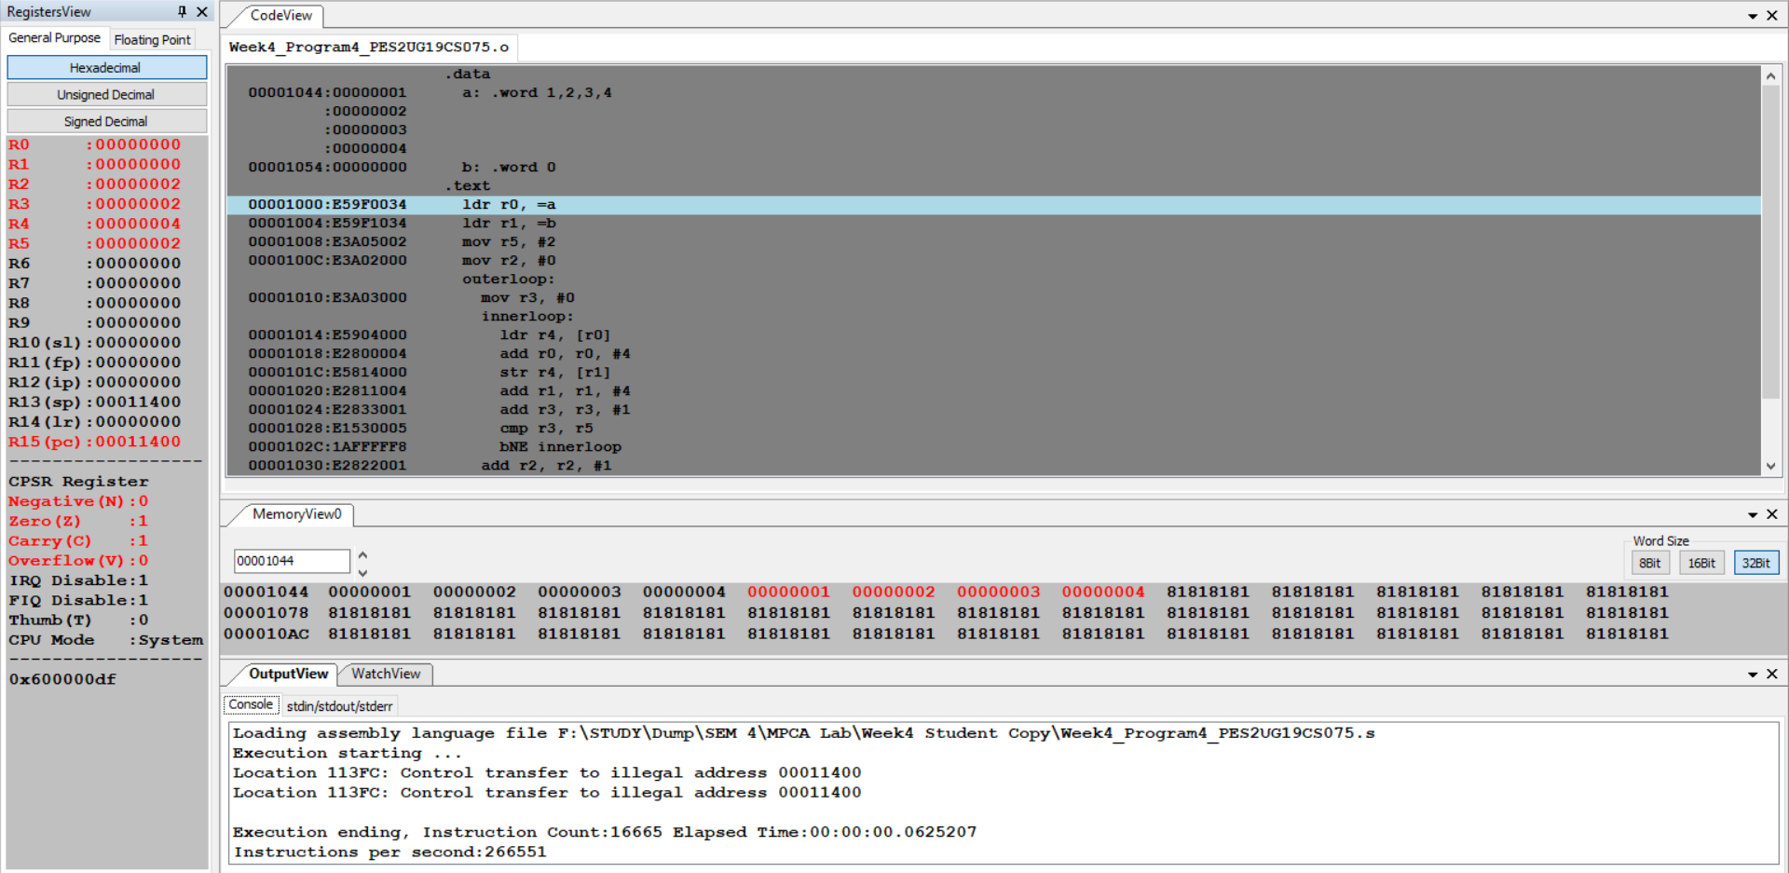

1. Output Table for the program(1)

|  |  |  |
| --- | --- | --- |
| Before execution | a: .word 1,2,3,4 | b: .word 0 |
| **After Execution** | **00000001** | **00000001** |
| **00000002** | **00000002** |
| **00000003** | **00000003** |
| **00000004** | **00000004** |

Week#4

Program Number: 5

**Write an ALP to implement C[i][j]=a[i][j]+b[i][j]**

1. ARM Assembly Code (1).

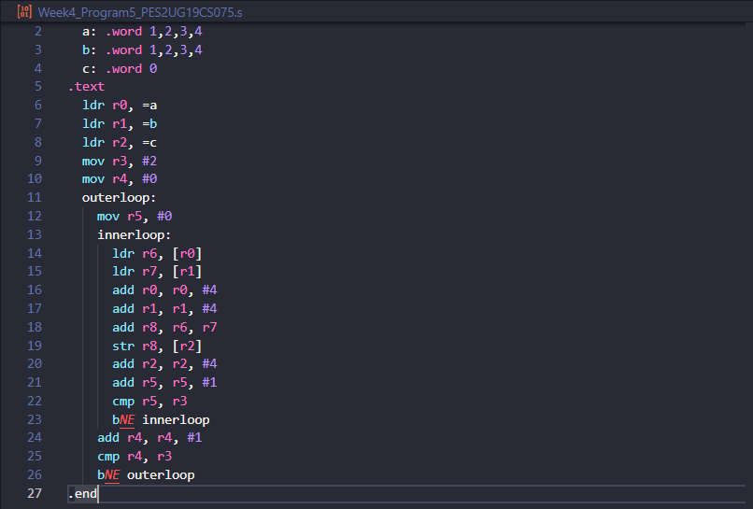

1. Output Screen Shot (One Example of your choice)

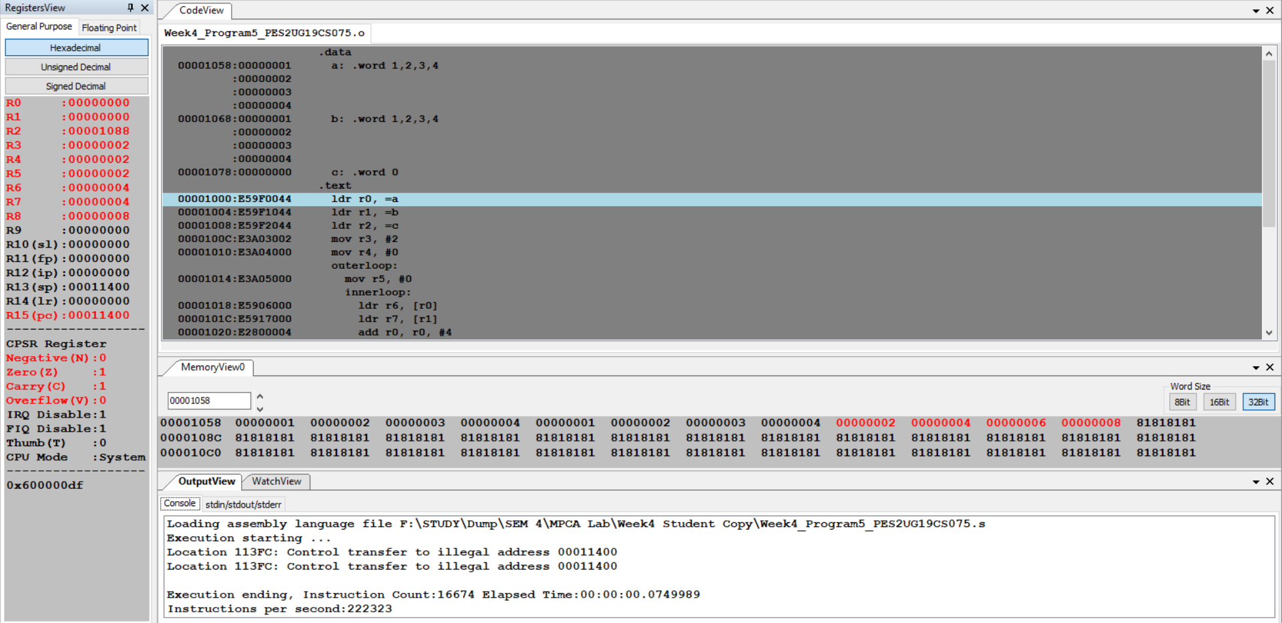

1. Output Table for the program(1)

|  |  |  |  |
| --- | --- | --- | --- |
| Before execution | a:.word 1,2,3,4 | b:.word 1,2,3,4 | c:.word 0 |
| **After Execution** | **00000001** | **00000001** | **00000002** |
| **00000002** | **00000002** | **00000004** |
| **00000003** | **00000003** | **00000006** |
| **00000004** | **00000004** | **00000008** |

Week#4

Program Number: 6

**Write an ALP to implement Sum[i] +=a[i][j]**

1. ARM Assembly Code (1).

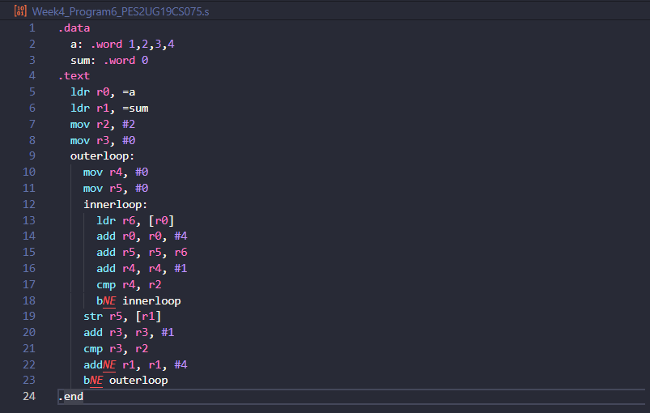

1. Output Screen Shot (One Example of your choice)

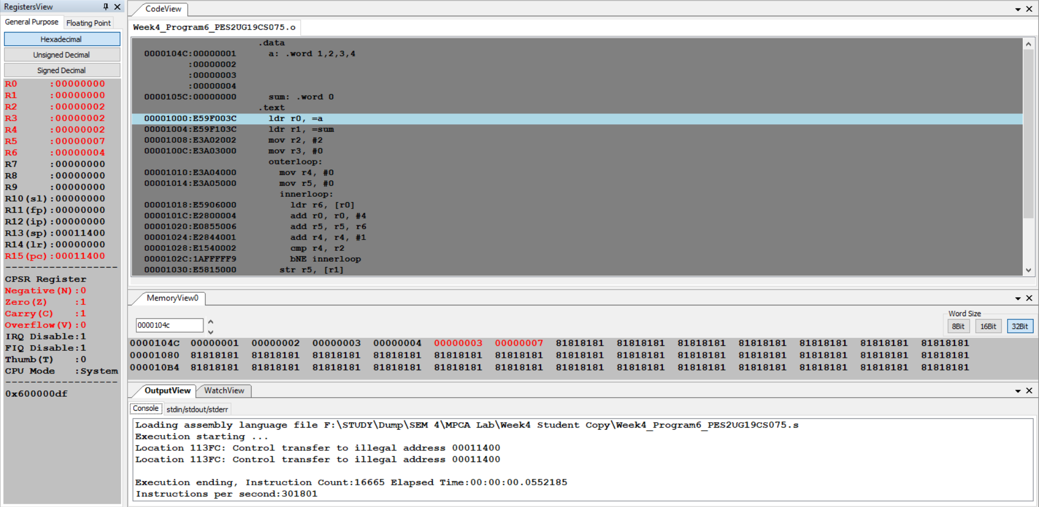

1. Output Table for the program(1)

|  |  |  |  |
| --- | --- | --- | --- |
| **Before execution** | **a:.word 1,2,3,4** | | |
| **After Execution** | **Addition result** | **Sum[0]=3** | **Sum[1]=7** |

**Disclaimer:**

* The programs and output submitted is duly written, verified and executed by me.
* I have not copied from any of my peers nor from the external resource such as internet.
* If found plagiarized, I will abide with the disciplinary action of the University.

Signature: Atul Anurag

Name: Atul Anurag

SRN: PES2UG19CS075

Section: B

Date: 19-02-2021